**Assignment 1 Physics Report**

Shila Das and Cody Edwards

Question:

Over a completely flat surface a thermal detonator (Star Wars) is thrown by a wookiee (a member of the rebel alliance) towards a group of imperial stormtroopers. The thermal detonator always leaves the wookiee’s hand with a speed of 95m/s and the thermal detonator has a mass of 2.2Kg.

1. Suppose that the Stormtroopers are 485m away. What is the correct angle for the wookiee to throw the thermal detonator so that it reaches the Stormtroopers.
2. What is the maximum distance the thermal detonator could travel?
3. Diagram:

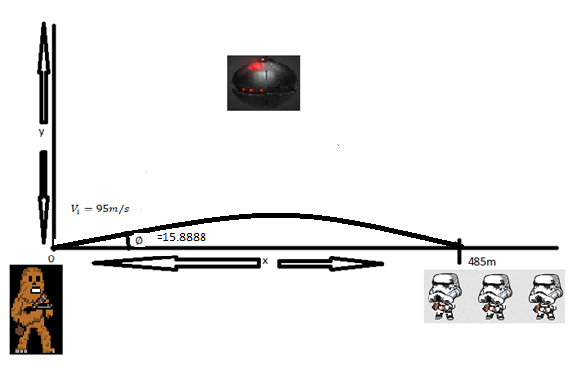

We know

$t=\frac{2v_{i}\sin{∅}}{g}$

and $∆x=v_{xi}t$

and

g=9.8m/s2

So,

Diagram:

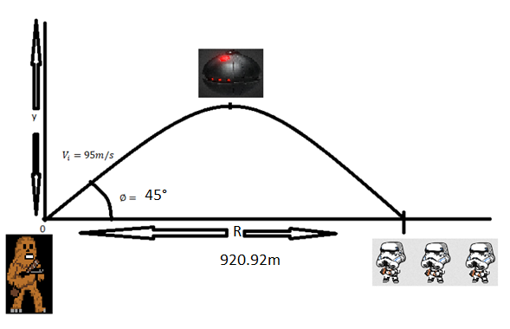

We know, this is symmetric trajectory. So,

Maximum range occurs at $∅=45°$

And $R=\frac{v_{i}^{2}\sin{2∅}}{g}=\frac{{95}^{2}\sin{(2*45°)}}{9.8}=\frac{9025*\sin{90}}{9.8}=920.92m$